Smart Car Parking System

# 1.Atharvan Chavan 2.Siddhesh Shivgan 3.Aakash Manjrekar

# Abstract

The main objective is to avoid the cramming in the car parking area by implementing an efficient car parking system along with a user-friendly application for an ease of use. Normally at public places such as multiplex theatres, market areas, hospitals, function-halls, offices and shopping malls, one experiences the discomfort in looking out for a vacant parking slot, though it’s a paid facility with an attendant/ security guard. The parking management system is proposed to demonstrate hazel free parking. The proposed system consist of 4 IR Sensors, Arduino UNO, NodeMCU ESP8266 Module, RFID Reader and Tags, Buzzer. Implementation involves minimal human interaction and provides a seamless parking experience thereby reducing a lot of time wasted by the user in parking his/her vehicle and displays the vacant slots on the display at the entrance of the parking so that the user gets to know the availability/unavailability of parking space prior to his/her entry into the parking place.

**Keywords:** RFID, IR Sensors, Arduino   
UNO, NodeMCU.

# INTRODUCTION

Nowadays in many public places such as malls, multiplex systems, hospitals, offices, market areas there is a crucial problem of car parking. The car-parking [1-4] area has many lanes/slots for car parking. So to park a car one has to look for all the lanes. Moreover, this involves a lot of manual labor and investment. So, there is a need to develop an automated parking system that indicates directly the availability of vacant parking slots in any lane right at the entrance. It involves a system including IR Sensors- receiver pair in each lane. So the person desirous to park his vehicle is well informed about the status of availability of parking slot. Conventional parking systems do not have any intelligent monitoring system and the parking lots are monitored by security guards. Conventional parking systems do not have any intelligent monitoring system and the parking lots are monitored by security guards.

A lot of time is wasted in searching vacant slot for parking and many a times it creates jams. Conditions become worse when there are multiple parking lanes and each lane with multiple parking slots. Use of parking management system would reduce the human efforts and time with additional comfort. In the proposed system, the display unit displays a visual representation of the parking and it shows the empty and occupied slots which help the user to decide where to park their car. The system would not only save time but the software and hardware would also manage the Check-in and check-outs of the cars under the control of RFID readers/ tags with additional features of entry exit data logging.

In this system, the users are guided to the vacant slot for parking by showing the empty slots on our app that we have developed at the entrance of the parking gate, Our App show a visual representation of the parking lot with empty and occupied slots which are green and red respectively. The user is provided with a tag which he receives on registration.

# OBJECTIVE

Now days in many public places such as malls, multiplex systems, hospitals, offices, market areas there is a crucial problem of car parking. The car-parking area has many lanes/slots for car parking. So to park a car one has to look for all the lanes. Moreover, this involves a lot of manual labor and investment. So, there is a need to develop an automated parking system that indicates directly the availability of vacant parking slots right at the entrance. It involves a system including IR Sensors- receiver pair in each lane. So the person desirous to park his vehicle is well informed about the status of availability of parking slot. Conventional parking systems do not have any intelligent monitoring system and the parking lots are monitored by security guards. So the person desirous to park his vehicle is well informed about the status of availability of parking slot.

# Motivation

The main motivation for making Car Parking System is because of the huge amount of time people have to take in order to park their cars in malls, multiplex systems, hospitals, offices and super markets. In the existing system, one has to spend ample time before they find out an empty parking spot and also the conventional payment method requires the user to spend a lot of time to complete their transaction. Creating an automated system which not only helps users to make parking much more efficient and faster but also automates the payment gateway using RFID thus saving the user a lot of time.

# Description

It proposes a prototype of Car Parking System with various personalized features. The sensor used in this project is an 4 IR sensors which determines whether the slot is occupied or unoccupied. These sensors are connected to the Arduino UNO. The output of these sensors is sent to the database through the NodeMCU ESP8266. Once the database is updated the result is displayed on the Mobile Application that we have developed at the entrances of the parking level. Each second Firebase database is updated with latest values from IR Sensors. This result is displayed using the Mobile Application. As soon as the vehicle passes through the entry gate the RFID Reader reads the tag and gets the Unique ID and then logs an entry into the database.

Flutter Dart Language is used to design the software aspect of this project. This involved designing interface for the users to check the available slots in the parking lot. Similarly, the app is designed using the Flutters software.

The smartphone application provides the user with an interface to interact with the device. The application provides the user real time reading of the available slots. If the slot is empty it display that the slot is empty in the app and if the slot is full it will display there is no parking slot available. Thus saving the time of the users. The hardware consists of two Arduino UNO, 4 IR Sensors, one RFID Reader, Jumper wires and RFID Tags one NodeMCU ESP8266 , one Buzzer and one Breadboard. The IR Sensor is primarily responsible for detecting any object within its range. The RFID Reader is used to read data from the RFID Tags. The Arduino UNO and NodeMCU ESP8266 acts as an interface between the hardware and the software.

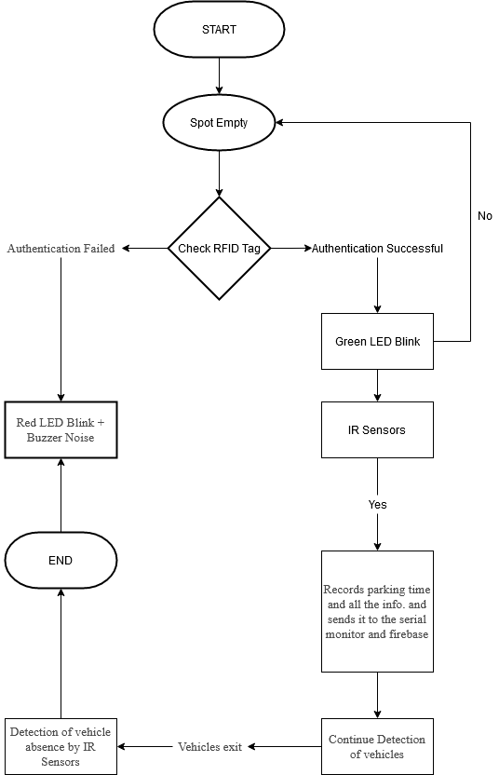

The hardware comprises of 4 IR Sensors, Arduino UNO and RFID Reader/Tags which communicates with each other and is rendered on our Mobile Applications

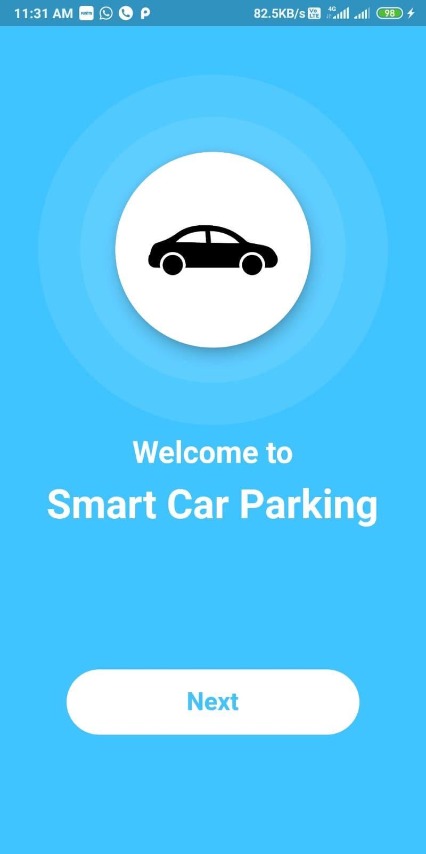 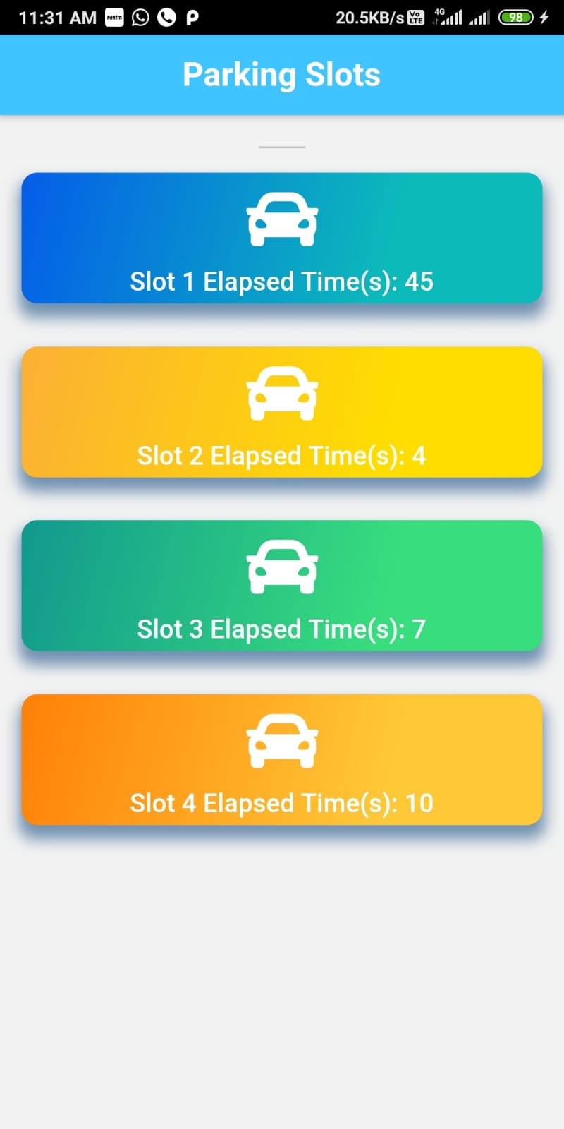

Software Design

# METHODOLOGY

**Overall Design:**

The Overall Engineering Design is described in the figure 2. The hardware comprises of IR Sensors, Arduino UNO, NodeMCU ESP8266 and RFID Sensors which communicates with each other and is rendered on various Applications such as the Firebase which we are using as the backend for our application where all user’s data will be stored and on Mobile Application that we have developed. This detailed architecture explains about the entire working system of the efficient car parking model with various personalized features. The sensor used in this project is an 4 IR sensors which determines whether the slot is occupied or unoccupied. These sensors are connected to the Arduino UNO. The output of these sensors is sent to the database through the Arduino UNO / NodeMCU ESP8266.

Once the database is updated the result is displayed on the Mobile Application at the entrances of the parking level. Each second Firebase database is updated with latest values from IR Sensors. This result is displayed using the Mobile Application. There will be an RFID Tag with every user. As soon as the vehicle passes through the entry gate the user will put the RFID tag on RFID Sensor/Reader then RFID Reader reads the tag and gets the Unique ID and then logs an entry into the database.

The hardware consists of two Arduino UNO, 4 IR Sensors, one RFID Reader, Jumper wires and RFID Tags, One NodeMCU ESP8266, One Buzzer, Two LED Lights, BreadBoard. The IR Sensor is primarily responsible for detecting any object within its range. The RFID Reader is used to read data from the RFID Tags. The ArduinoUNO and NodeMCU ESP8266 acts as an interface between the hardware and the software.

When the IR Sensors detect any vehicles in the parking slots, the IR Sensor sends a signal to the NodeMCU ESP8266. According to the output from the IR Sensor the NodeMCU ESP8266 runs a particular link to update the database in the firebase. Changes from occupied to unoccupied the IR Sensor detects no object in front of it and hence sends a signal to the NodeMCU ESP8266 and NodeMCU ESP8266 runs the Mobile Application “Smart Car Parking” Where the slot number indicates the availability of the slot.

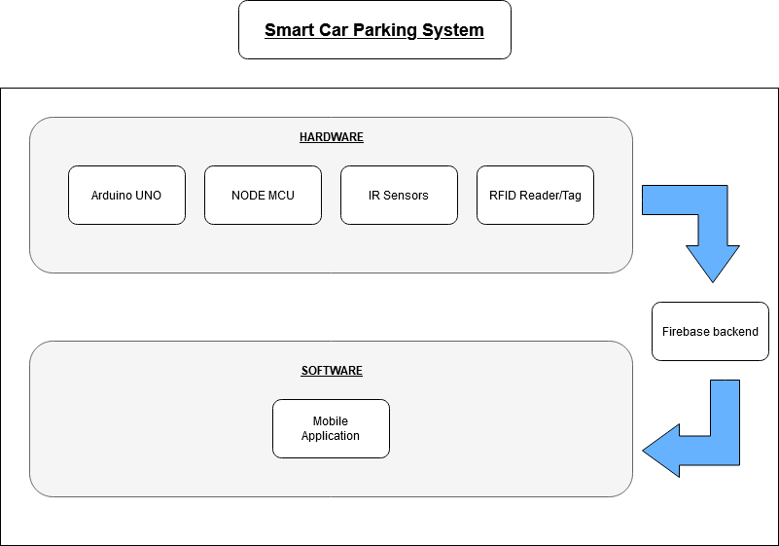

**Figure 2:** Architecture

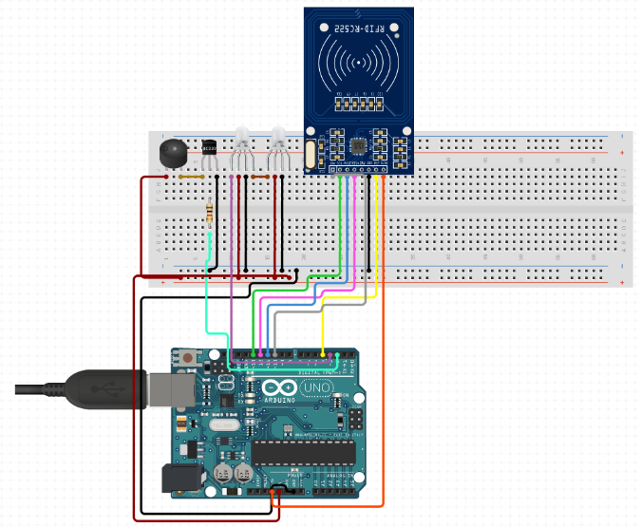

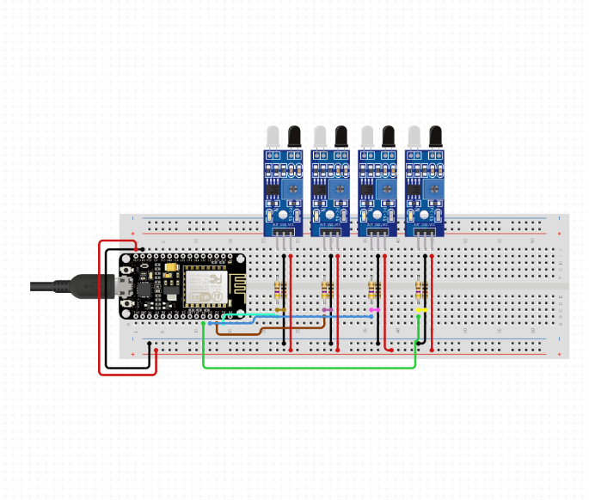

**Figure 3:** Hardware Design

# CONCLUSION

The main aim is to design an integrated system which involves two components namely Parking Allocation and Seamless Parking. The Parking Allocation component consists of sensors in front each slot and when a vehicle enters into the slot, the database is updated and the changes are reflected immediately on the nearby display. The seamless parking component consists of a RFID Tag with user. It will save the time of human intervention and saving an ample amount of time. We have interfaced 4 IR Sensors and an RFID Reader module (RC-522) using a Arduino UNO and NodeMCU. The IR senses the presence of a vehicle in the parking slot and updates the database. We have made an android application. We have 4 IR Sensors and an RFID Reader module (RC-522) using a Arduino UNO and NodeMCU ESP8266. The IR senses the presence of a vehicle in the parking slot and updates the database. The RFID is used for identification and transaction. We have made an android application to further simplify the process of getting data about the parking slot availability and effort less parking.

# REFERENCES

1. Karma Tsheten Dorjee , Deepak Rasaily , Bishal Cintury

,RFID-Based Automatic Vehicle Parking System Using Microcontroller,IJETT,Volume 32 , Number 4, February

2016.

1. R.Kannadasan, A.Krishnamoorthy, N.Prabakaran, K.Naresh, V.Vijayarajan, G.Sivashanmugam,RFID Based Automatic Parking System , Australian journal of basic and Applied Sciences , Volume 10(2) ,Pages: 186- 191,February 2016.
2. S. C. Hanche, Pooja Munot, Pranali Bagal, Kirti Sonawane & Pooja Pise, Automated Vehicle Parking System using RFID, ISSN (PRINT) : 2320 – 8945, Volume -1, Issue -2, 2013.
3. Lanxin Wei; Qisheng Wu; Mei Yang; Wei Ding; Bo Li; Rong Gao ,Design and Implementation of Smart Parking Management System Based on RFID and Internet, Pages: 17 - 20, Year: 2012.
4. Kartha, V., George, L., Tomy, A., Mathew, F., Shenoy,

M. and K, A. (2017). Interfacing EM-18 RFID Reader Module with Raspberry Pi. [online] electroSome. Available at: https://electrosome.com/em-18-rfid-reader- raspberry-pi/.

1. Raspberrypi.org. (2017). Raspberry Pi Forums. [https://www.raspberrypi.org/forums/viewtopic.php?f=28 &t=148244&p=975479](https://www.raspberrypi.org/forums/viewtopic.php?f=28&t=148244&p=975479)
2. Start Bootstrap. (2017). Freelancer - One Page Theme. https://startbootstrap.com/template-overviews/freelancer/.
3. Kartha, V., George, E. and George, L. (2017). Using UART on Raspberry Pi - Python - pySerial. [online] electroSome. Available at: https://electrosome.com/uart- raspberry-pi-python/
4. Raspberrypi.stackexchange.com. (2017). Raspberry Pi Stack Exchange. https://raspberrypi.stackexchange.com/